**Name: Jomol R.k**

**Roll No: 09**

**Batch:S2 MCA B**

**Date:06/06/2022**

**NETWORKING & SYSTEM ADMINISTRATION LAB**

**Experiment No.: 26**

**Aim**

**Networking commands**

**Procedure**

ip config:

Basic details of system connected to a network

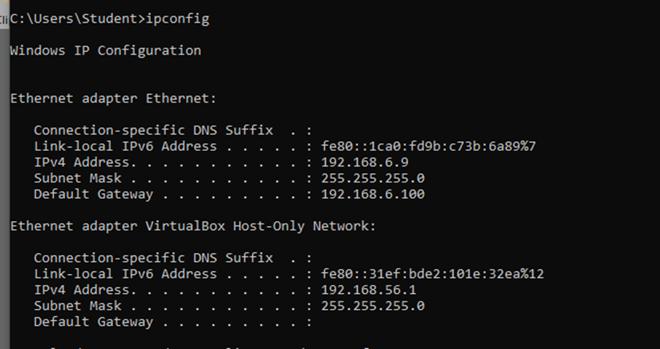

ipconfig/all:

Detailed study of system connected to network

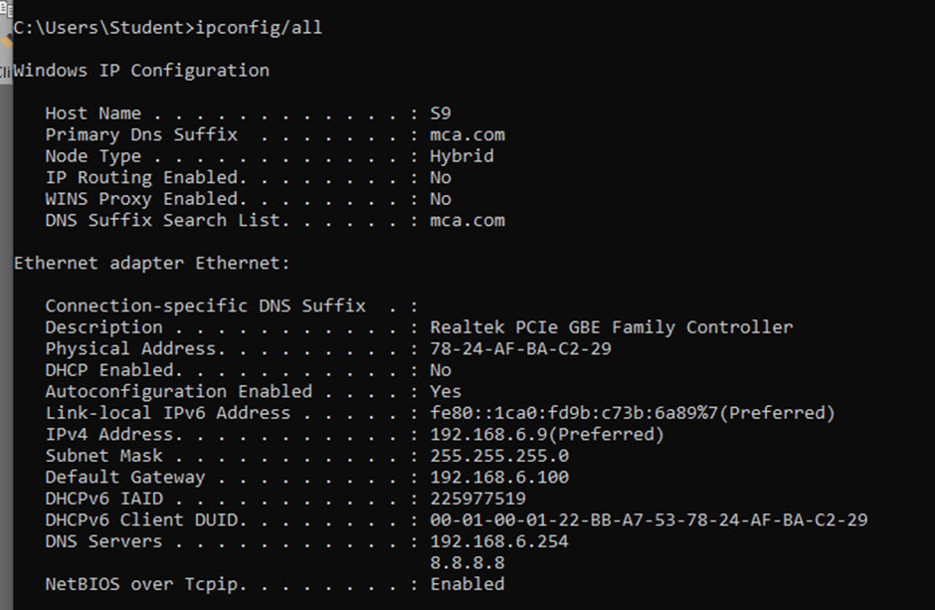

nslookup:

connect to which server

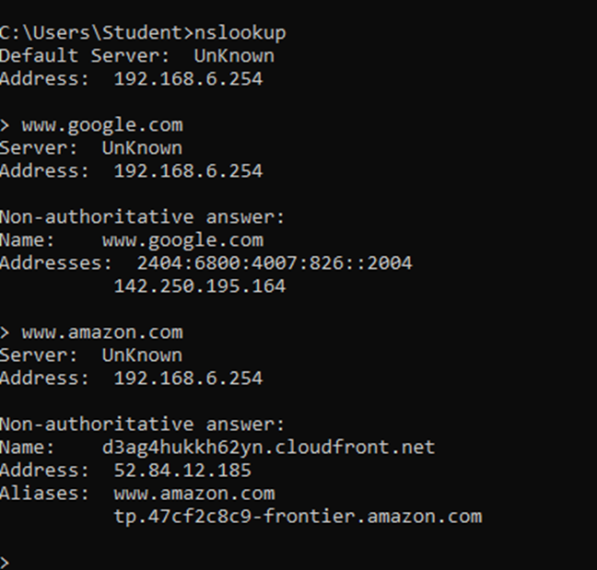

Ping:

identify the destination host

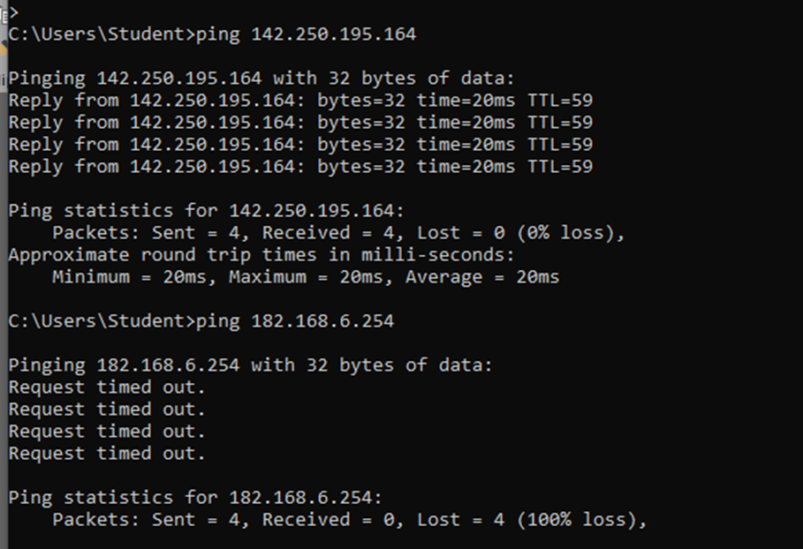

Tracert:

How many router ie needed to overcome to reach destination

traceart “ip address”

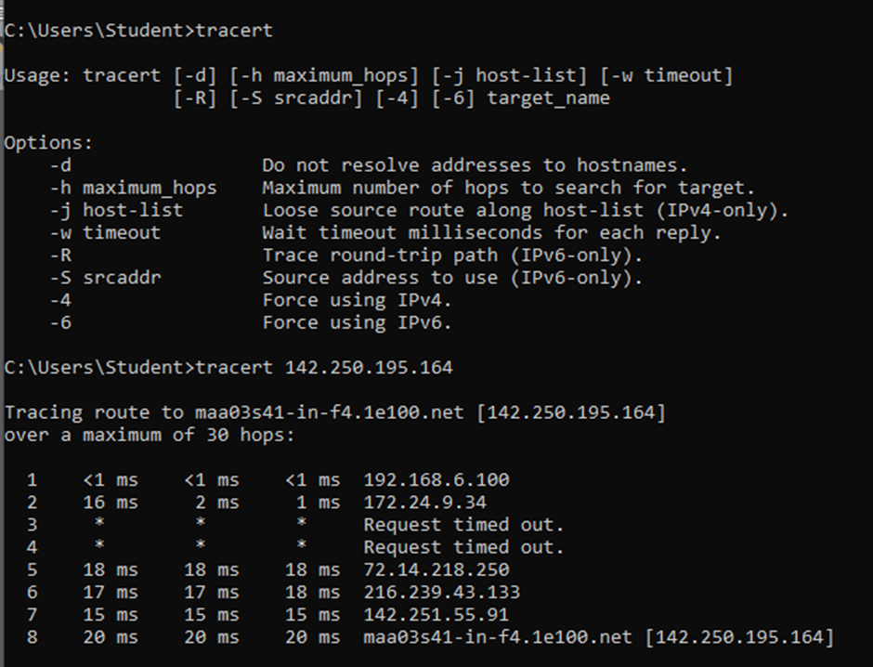

route print:

to access our system routing table

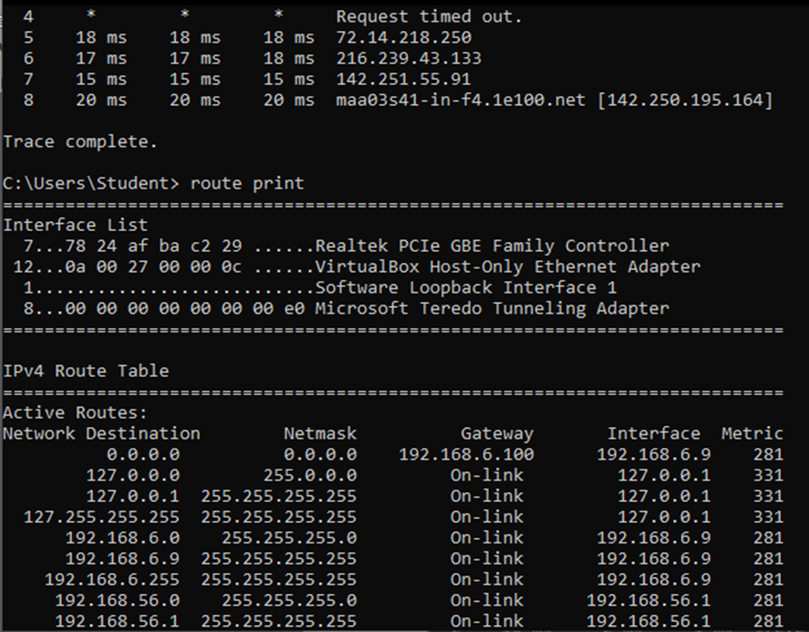

netstat:

the available number of connection through tcp and udp

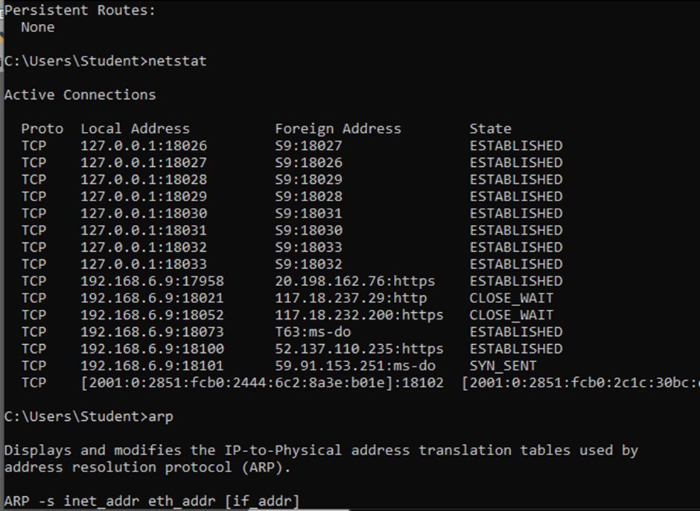

arp:

arp command manipulates the System’s ARP cache. It also allows a complete dump of the ARP cache. ARP stands for Address Resolution Protocol. The primary function of this protocol is to resolve the IP address of a system to its mac address, and hence it works between level 2(Data link layer) and level 3(Network layer).

